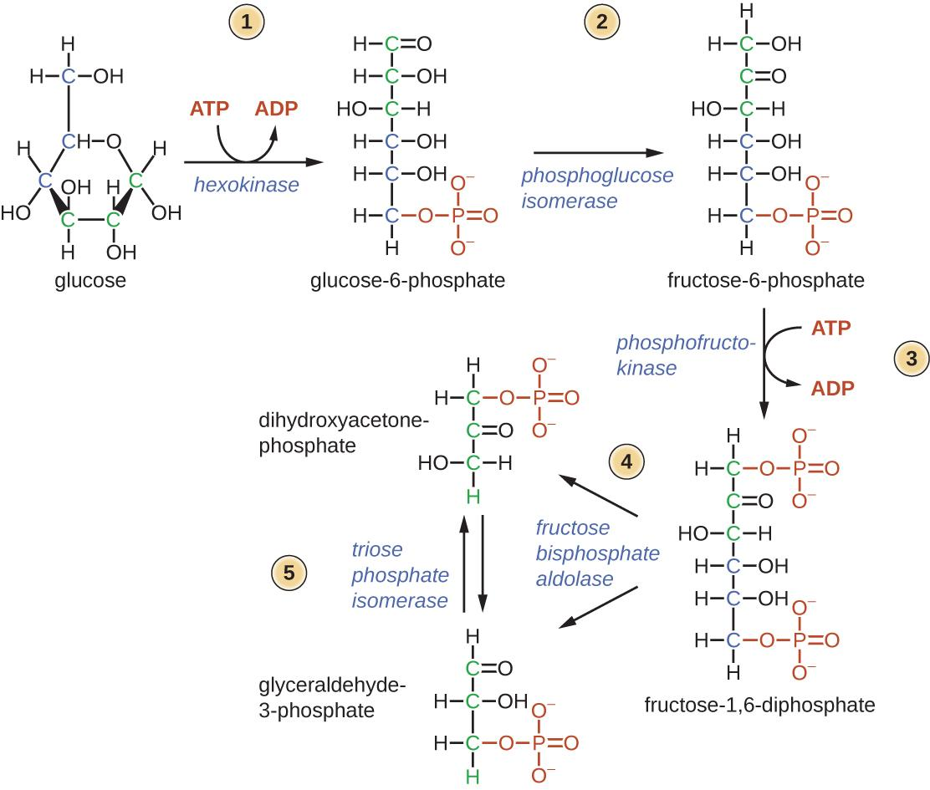
Relationship between PGI and HSPs

Scientists have not worked out the link between PGI and the heat shock response, but this is an active area of study in many model systems. To understand how heat shock proteins affect organismal performance, scientists have established a few facts about proteins specifically and PGI and HSPs specifically. These facts include:
- PGI is an enzyme (a type of protein) that catalyzes a step in the glycolysis pathway.
- Heat causes proteins to misfold.
- Misfolded proteins activate heat shock factors.
- Heat shock factors initiate transcription of heat shock proteins.
- Heat shock proteins bind to misfolded proteins and help them refold.

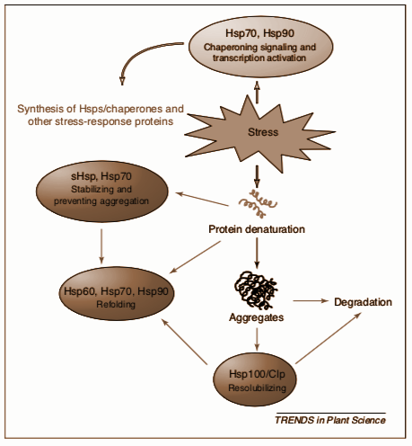
There are 2 major hypotheses about how PGI is related to HSPs. One hypothesis is that since PGI is such an abundant and important protein in the cell, its degradation produces a very strong signal promoting a heat shock response (in order to refold the PGI). A second hypothesis is that it is possible that PGI has an additional function beyond its role in the glycolysis pathway. This other function in the cell has not been fully fleshed out, but there is some evidence that it could be a growth factor.

Wang et al. (2004) has published the diagrams shown on the right that encapsulates most of these points and the figure on the next page proposes a possible mechanisms of crosstalk with metabolic pathways. In this case, PGI could be a signaling molecule. Even though the work by Wang et al. is about plants, the same principles apply.
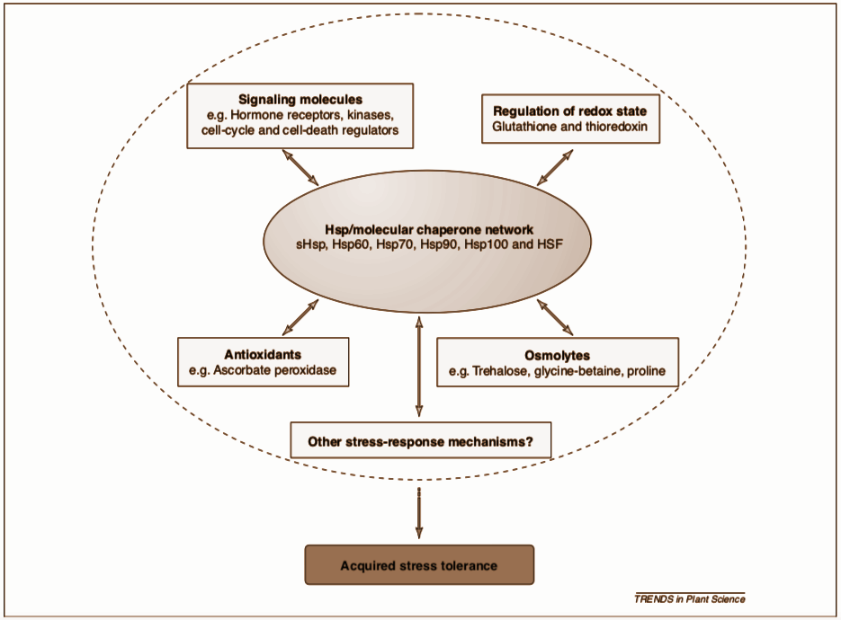
- Review the glycolysis pathway.
  - Describe an organism’s ability to process glucose if PGI is degraded.

  - Make a claim about an organism’s ability to survive if PGI became less functional or completely degraded.

  - Justify the claim you made in part b.

- Consider the two hypotheses described above.
  - Identify which hypothesis you would choose to test first.

  - Propose an experiment that could be used to test this hypothesis.

First image from OpenStax Microbiology, licensed under Creative Commons. Other images reproduced with permission from Wang, W. et al (2004) Role of plant heat-shock proteins and molecular chaperones in the abiotic stress response. Trends Plant Sci. May;9(5):244-52.

