Population Differences & Hardy-Weinberg Equilibrium

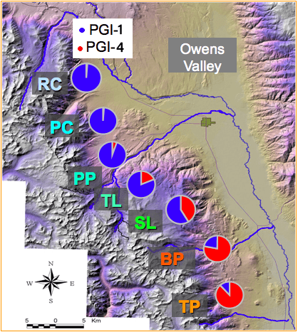
Researchers further explored the PGI alleles’ relationship to fitness by analyzing the allele frequencies found at 7 separate locations in the Sierra Nevadas. These locations were North to South: Rock Creek (RC), Pine Creek (PC), Piute Pass
PGI alleles change in frequency over a 70km latitudinal transect
(PP), Tyee Lake (TL), South Lake (SL), Big Pine (BP), and Taboose Pass (TP). As the latitude changed, so did the allele frequencies as shown on the right. The notation PGI-F is the same as the PGI-1 allele and the PGI-M is the same as the PGI-4 allele.

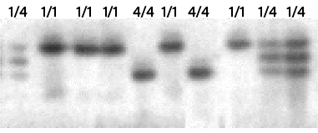
To the right is a gel that was run to identify alleles of beetles from one of the locations. You can see that there are some beetles that are homozygous for the PGI-F allele, some are homozygous for the PGI-M allele, and some are heterozygous.

At one specific site, the South Lake location, the beetle population was sampled in 1988 and 1996 to see if the allele frequencies were in equilibrium or if the population was changing. The Hardy-Weinberg equilibrium model describes and predicts allele frequencies in a non-evolving population. The conditions for population equilibrium include: large population size, no migration, no net mutations, random mating, and no natural selection. These conditions are rarely met.
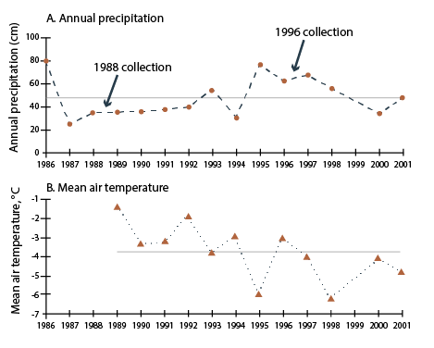
The researchers also tracked the annual precipitation and mean air temperature over time for this location. They were able to capture and identify a sample of 518 beetles from the population in 1988 and a sample of 366 beetles from the population in 1996.

Use the data above to answer the following questions:
- Examine the map showing the PGI allele frequencies at the 7 different locations.

  - Make a claim about the pattern shown by the allele frequencies.

  - Justify your claim from part (a) by providing evidence to support, qualify, or defend your claim, and explain the underlying scientific principle that supports the claim.

- Examine the annual precipitation and mean air temperature graphs. Also consider the conditions necessary to maintain Hardy-Weinberg Equilibrium.
  - Describe the trend of the data in the annual precipitation and mean air temperature graphs.

  - Make a prediction about whether the allele frequencies will remain relatively stable (in equilibrium) or if the allele frequency will change over time. Discuss one or more of the conditions of Hardy-Weinberg equilibrium when making your prediction.

References:
Rank, N.E. & Dahlhoff, E.P. (2002) Allele frequency shifts in response to climate change and physiological consequences of allozyme variation in a montane insect. Evolution 56, 2278–2289.

Dahlhoff, E. P. et al (2008). Effects of Temperature on Physiology and Reproductive Success of a Montane Leaf Beetle: Implications for Persistence of Native Populations Enduring Climate Change. Physiological and Biochemical Zoology, 81(6): 718-732.

Images adapted from the above sources and modified with permission from Nathan Rank.

