Performance and Cell Respiration

Running speed for willow beetles is a performance character that can be used to assess the energetic allocation of different PGI genotypes. In 2007, Rank et al. published the paper “Phosphoglucose isomerase genotype affects running speed and heat shock protein expression after exposure to extreme temperatures in a montane willow beetle” in The Journal of Experimental Biology. This article compiled the running speed data for adults and larvae of the different PGI genotypes of the Sierra willow leaf beetle. The experiments used to determine the effects of exposure to thermal extremes on beetle running speed and Hsp70 expression involved a total of 480 beetles. First, they collected beetles from the wild and completed an initial running speed measurement. Next, the beetles were divided into three temperature-treatment groups: -4ºC, 20ºC, and 36ºC. Each of these temperature groups were further subdivided to get a second temperature treatment of -4ºC or 36ºC. Running speed were measured immediately after collecting beetles from the field and then again after two days of consecutive 4·h temperature treatments. Larvae were also tested, though their sample size was half as large as the adult beetles. The only other difference between experiments was that the larval heat-treatment temperature was 35°C.

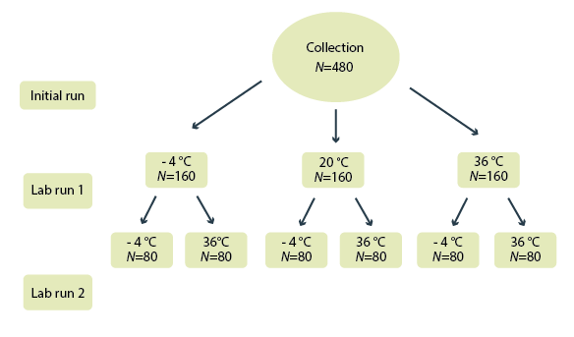

The data produced show a complicated story, but the data does support the race car/jeep analogy Rank and Dahlhoff came up to compare beetles with the PGI1 or PG4 alleles. Beetles with PGI-1 were the “race cars,” speeding ahead when the temperature was normal or after a minor challenge. However, after thermal stress the beetles PGI-1 ran out of fuel, and PGI 4-4 beetles, which don’t waste a lot of energy on HSPs, were much faster.

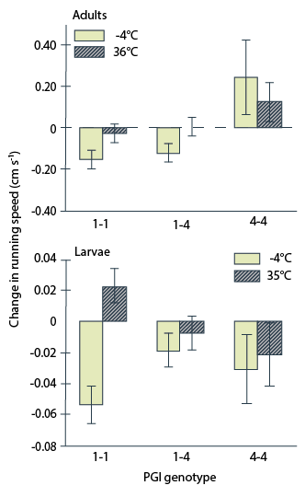
The clearest figures that illustrate their findings are shown below.
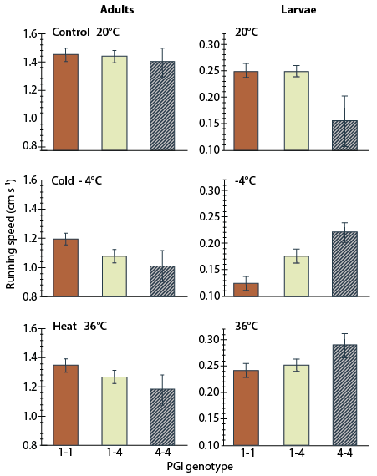
Differences in adult and larval running speed measured after first and second temperature treatments.
Differences among PGI genotypes in effect of first temperature treatment on running speed in adults and larvae

Use the data above to answer the following questions:
- Consider the experimental design used by these researchers.
  - Identify how the researchers established a baseline for willow beetle respiration.

  - Identify what are the Independent and dependent variables in this experiment?

  - Determine the environmental conditions this experiment look to model?

- Examine figure 7 which shows the data collected for the “initial run” of the beetles.
  - Identify which stage of the beetles life cycle (larvae or adult) appears to have a more statistically significant difference between organisms with the 1-1 vs. the 4-4 genotype.

  - Justify your answer to part a using the data presented.

- Consider the race car/jeep analogy. Determine which data best supports this analogy.

Images adapted from Rank, N.E. et al (2007) Phosphoglucose isomerase genotype affects running speed and heat shock protein expression after exposure to extreme temperatures in a montane willow beetle. Journal of Experimental Biology 210: 750-764.

